Sponsor Benefits List

Premier $7,500 (only 1 available)  - Exclusive billing as “In association with…” in conference  marketing, website and program  - Welcoming remarks at the Luncheon  - Complimentary registration for 3 company representatives  - Full-page advertisement (inside cover) in conference notebook  - Preferred placement of Company logo on all conference bags  - Company name or logo on attendee name tags  - Plus Suite of Benefits (listed in the yellow box to the right) | Suite of Benefits  In addition to level-specific benefits listed to the left, all sponsors will also receive all of the following items:  - Recognized in all conference marketing  - Introduce a workshop session speaker  - Draped table in the Sponsor  Atrium with ample foot traffic throughout the conference  - Rolling credits throughout the Plenary and Luncheon Programs on the “big screen”  - Promotional literature  and token inside each participant’s conference bag  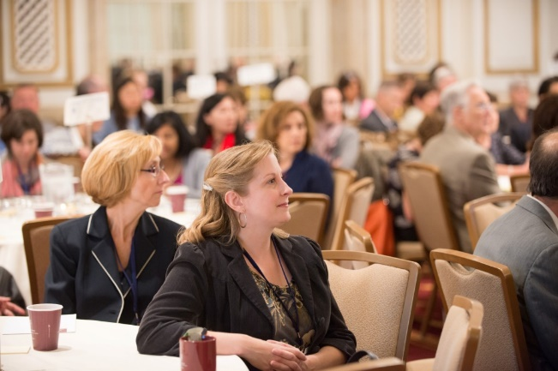  Please see the next page  for a “ Benefits At-A-Glance”  comparison chart.
Platinum $5,000 (only 2 available)

- Sponsor of Conference Plenary or Luncheon Keynote
- Introduce Plenary or Luncheon Keynote Speaker
- Complimentary registration for 3 company representatives
- Exclusive sponsor of one of five monthly Council Luncheon Programs offered during 2016
- Full-page advertisement in conference notebook
- Placement of Company logo on all conference bags
- Company name or logo on attendee name tags
- Plus Suite of Benefits (listed in the yellow box to the right)
Gold $4,000 (only 4 available)

- Sponsor one of the following:
- Scholarships with remarks at the Luncheon Program
- Reception with remarks at the Wrap-up Reception
- Networking Breakfast with appropriate signage
- WiFi Accessibility with appropriate signage
- Complimentary registration for 2 company representatives
- Full-page advertisement in conference notebook
- Company name or logo on attendee name tags
- Plus Suite of Benefits (listed in the yellow box to the right)
Silver $2500 (multiple available)

- Complimentary registration for 2 company representatives
- Half-page advertisement in conference notebook
- Plus Suite of Benefits (listed in the yellow box to the right)
Bronze $1500 (multiple available)

- Complimentary registration for 1 company representative
- Quarter-page advertisement in conference notebook
- Plus Suite of Benefits (listed in the yellow box to the right)

Sponsor Benefits At-A-Glance

Premier  $7,500  One Available | Platinum  $5,000  Two Available | Gold  $4,000  Four Available | Silver  $2,500  Multiple Available | Bronze  $1,500  Multiple Available | Sponsorship Benefits
X |  |  |  |  | Exclusive billing as “In association with…” in conference marketing, website and program
X |  |  |  |  | Welcoming remarks at the Luncheon
Preferred | X |  |  |  | Company logo or name on conference tote bags
 | X |  |  |  | Exclusive sponsor of one of five monthly Council Luncheon Programs to be offered during 2016
Preferred | X | X |  |  | Name or logo on attendee name tags
 | X |  |  |  | Sponsor of Plenary or Luncheon Keynote Program
 | X |  |  |  | Introduce Plenary or Luncheon Keynote Speaker
 |  | X |  |  | Sponsor one of the following:  - Scholarships with remarks at Luncheon  - Reception with remarks at Wrap-Up Reception  - Networking Breakfast with appropriate Signage  - WiFi Accessibility with appropriate Signage
3 | 3 | 2 | 2 | 1 | Complimentary conference registration(s)
Full Page  (inside cover) | Full Page | Full Page | 1/2 Page | 1/4 Page | Advertisement in the conference notebook
Preferred | X | X | X | X | Recognized in all conference marketing
X | X | X | X | X | Introduce a workshop session speaker
X | X | X | X | X | Draped table in the Sponsor Atrium with ample foot traffic throughout the conference
X | X | X | X | X | Rolling credits throughout the Plenary and Luncheon Programs on the “big screen”
X | X | X | X | X | Promotional literature or tokens inside each participant’s tote bag

Key Features
2016 NCPGC Conference Sponsorship

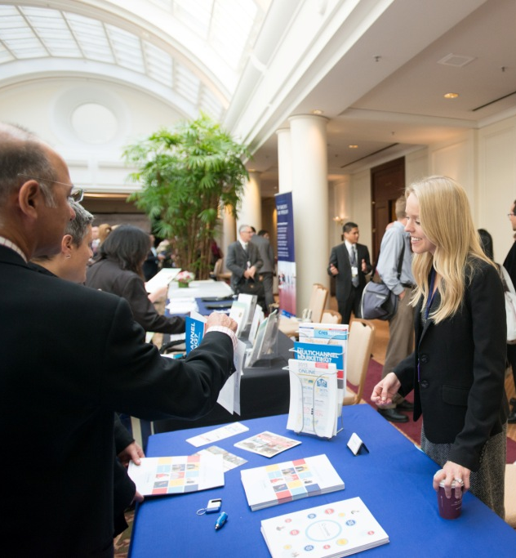
- The NCPGC’s annual conference attracts over 360 professionals whose clients closely match your business demographic.
- You will benefit with significant exposure on the “big screen” and personal interactions at your own booth throughout the day among conference participants from all over Northern California.
- Your professional interactions will continue at the networking breakfast, plenary and luncheon programs, workshop sessions, breaks between sessions and the reception.
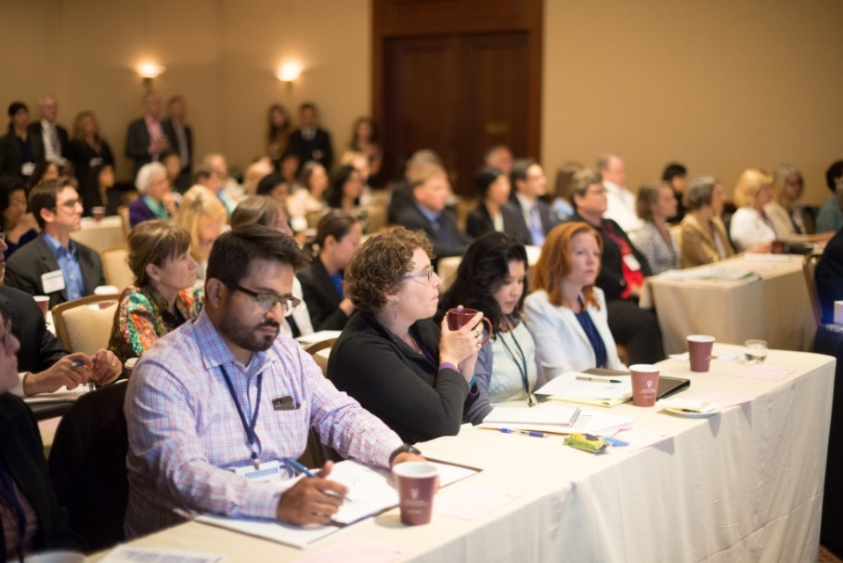
- You will receive complimentary tickets to attend the conference.
- You will be associated with and supporting one of the most respected and responsibly organized planned giving conferences in the nation.
- Plus a rich array of additional benefits.

Sponsorship Commitment Form

Sponsor Information:

Company:

Contact Name:

Contact’s Job Title:

Address
including city/state/zip:

Phone: |  | e-Mail:

Sponsorship Level:
Please select your sponsorship level below:
Please note: Sponsorships are on a first-come, first-served basis.

$7,500 Premier Sponsor (one available)

$5,000 Platinum Sponsor) (two available)
(Place a 1 or 2 into each box in order of preference Plenary Luncheon

$4,000 Gold Sponsor (Place a 1,2,3 or 4 into each box below in order of preference
Reception WiFi Scholarships Networking Breakfast

$2,500 Silver Sponsor

$1,500 Bronze Sponsor

Sponsor benefits begin once your commitment form is received

Please e-Mail or FAX this form to reserve your sponsorship level:
e-Mail: info@NCPGCouncil.org FAX: 415-983-2599

INVOICE FOR 2016 SPONSORSHIP OF THE 24th ANNUAL
NORTHERN CALIFORNIA PLANNED GIVING CONFERENCE

INVOICE
(THIS IS FOR YOUR RECORDS)

September 30, 2015

Amount Due:

$7,500 Premier Sponsor (includes three company representative registrations)
$5,000 Platinum Sponsor (includes three company representative registrations)
$4,000 Gold Sponsor (includes two company representative registrations)
$2,500 Silver Sponsor (includes two company representative registrations)
$1,500 Bronze Sponsor (includes one company representative registration)

Checks payable to: NCPGC or Northern California Planned Giving Council.

The tax identification number for the Northern California Planned Giving Council is 94-3233277.

Mail or Fed Ex to: NCPGC
14814 Bronson Avenue
San Jose, CA 95124

Please note: Your sponsorship benefits begin when your commitment form is received. Remember that sponsorship is available strictly on a first come, first served basis, based on the day we receive your commitment.

Questions?
Please contact Dawn Carroll at (415) 738-8438 or info@ncpgcouncil.org

