NCPGC Mission

The Northern California Planned Giving Council is a professional organization dedicated to:

- Encouraging charitable gift planning;
- Promoting a wider understanding of charitable gift planning by both non-profit and for-profit practitioners; and
- Raising the technical skills and professional competence of charitable gift planners.

Council members are non-profit gift planners, attorneys, consultants, CPAs, financial planners, insurance agents, stock brokers, trust officers, and professional advisors, as well as other persons interested in planned giving.

NCPGC Conference

Each year, NCPGC hosts a one-day Conference for those interested in sharpening their skills and to network with others in the field. Workshops are available for all levels of planned giving experience including Fundamentals, Masters, Marketing, Technical and Administration tracks.

When: Monday, May 2, 2016, 8:00 a.m. – 5:30 p.m.
Where: The Palace Hotel, San Francisco

NCPGC Conference Scholarships

The Conference Committee is pleased to announce that ten scholarships are available this year. The aim of this scholarship program is to strengthen the planned giving capacity of organizations, particularly those that might not be able to participate in the conference but for the scholarship. Applicants should work within organizations that:

- Have begun or are considering developing a planned giving program in their organization.
- Have the support of the Board of Directors and/or Executive Director.
- Have the organizational and staff interest and motivation to build a planned giving program.
- Special consideration will be given to applications from individuals who work for organizations which serve underrepresented and economically disadvantaged communities and whose boards of directors and staff demonstrate a high degree of diversity.

Applications must be received by Aprll 10, 2016.
Qualifying recipients will be notified by April 15, 2016. Scholarships Sponsored by
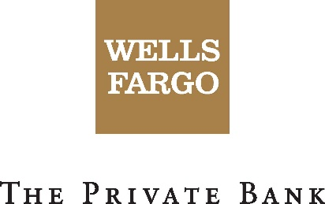

If you have any questions or would like additional information, please contact
Dawn Carroll
(415) 738-8438
info@ncpgcouncil.org

We appreciate your interest in our Conference scholarship program. In order to help the Committee learn more about you and your organization, we ask all candidates to complete the following questions as part of the application process. Please take as much room as you need to provide the information requested below. You may use separate attachments if necessary. Please sign and date your completed application, and mail it to us at the address shown at the end of this form.

Be sure to SAVE THIS FORM to your computer BEFORE completing it!
1. Organization Name:
2. Name and Job Title Of Proposed Individual Attendee:
3. Postal Address and Email Address and Telephone:
4. Website (if any) URL:
5. Please describe the mission of your organization:
6. What are your organization’s budgeted revenue and expenses for the current fiscal year?
7. List your current funding sources by category (i.e. foundations, government, major
donors, individuals, etc.). Include the percent of total income each source provides.
8. Does your organization have a person assigned full time to development?
Yes No
If no, does your organization have a person who devotes more than 50% of his or her
time to development?
Yes No
9. a) How many directors serve on the board of your organization?
b) How many of your board members support your organization financially?
c) How many of your board members come from the community the organization serves?
10. For how many years has your organization had an active program dedicated to soliciting
contributions from individual donors?
11. How has your organization made a commitment to develop or implement a planned
giving program?
12. Is there any other information that you would like us to consider? Feel free to include any information or data that may qualify you under our special consideration goals.

Please send completed application to:
Dated:
info@ncpgcouncil.org

OR

fax: (415) 983-2599
Signature
Printed Name
Title

